**Micropolis project:**

**Re WP2: Local case studies**

**How we build Micropolis in Wawer district - Case studies from Wawerskie Centrum Kultury**

By Małgorzata Smoczyńska together with Micropolis Team from Wawerskie Centrum Kultury

*Table of content*

Introduction 1

Case study I: „The Factory of Art” – how to build a local identity around an extraordinary person 3

The background and objectives 3

Methods and activities 4

Project results 6

Case study II: “Pine that connects people” – how to activate among interesting and important local symbol 7

The background and objectives 7

Methods and activities 8

Project results 10

Case study III: “Active in Radość estate” (or „Active in Joy”) – culture that connects the community during crisis situations 11

Background and objectives 11

Methods and activities 12

Project results 13

Perspectives from the case studies 13

## Introduction

Wawerskie Centrum Kultury (WCK) is a local public cultural institution established in 2014, consisting of 7 branches in various parts of Wawer (that is the biggest district in Warsaw, inhabited by more than 77 000 people, situated on the right bank of Vistula River, surrounded by huge forests of Mazovian Landscape Park). Our main activities are the creation and dissemination of culture as well as the development of social and cultural activities of the residents of the Wawer district.

* In activities for adults, we focus on cultural education, developing interests, cultivating artistic passions and social activities.
* For adults and seniors, we offer art classes (painting, drawing, handicraft, dance, theatre, photography) and section-related activities related to their interests.
* We conduct lectures (scientific, travel, health or ecology), workshops (handicrafts, dance, art, music), we present performances, films and concerts for adult audiences.
* We run our own theatre and cabaret groups and choirs.
* We organize a neighbourhood meeting.
* We work closely with the University of the Third Age.

WCK is a center of local activity, creates a space for meetings of various environments, carrying out broadly understood cultural activities, enters into dialogue with the community, establishes relations with the nearest neighbours, responds to the needs of the District's inhabitants and finds appropriate, attractive tools to activate society.

Detailed information on the courses organized is available on the website: <https://www.wck-wawer.pl>

In our Case Study we present 3 projects that we evaluated as highly successful in the Micropolis context – as projects that build and connect the local community.

## Case study I: „The Factory of Art” – how to build a local identity around an extraordinary person

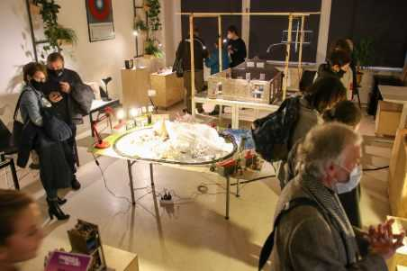

### The background and objectives

“The Factory of Art. 2:0” was an educational and artistic project initiated and carried out by young people from the Wawer district and the OP-ART Art Group, in tribute to Kazimierz Szpotański and important figures for Polish science and cultural heritage.

Szpotański turned out to be a great example of Wawer’s local hero - as a pioneer of Polish power engineering, an engineer, social worker and a model of a modern patriot. On the other hand, his story used to be quite unknown and had a great potential to be discovered and disseminated in this special project that involved a series of artistic workshops during which historical materials were collected and developed at the side of experienced artists.

Innovation consisted in the involvement of young people to create original projects using modern technologies, fascinating young people, while at the same time providing them with historical content relevant from the point of view of local heritage and the objectives of the program. The second, important issue was to show young people that by properly directing their interests, you can strengthen your community and spend your free time in an interesting way, but also achieve a lot in the field of interest to them - creating film forms, creating an art installation.

The substantive background of the project is based on young people discovering and presenting to the inhabitants of the district and Warsaw the extraordinary figure of Kazimierz Szpotański - his scientific, technological and social achievements.

The immediate goal was to carry out a series of workshops during which a short animated film and an art installation will be created. We also created a credible description in Wikipedia.

The indirect goals of the project was to awaken passion, promote modern patriotism and strengthen the social competence of the participants.

The project was related to the history of the entire so-called Otwocka Line (train connection through the whole Wawer district) at the beginning of the 20th century and responded to the need to build a common identity of the Wawerians, who have a relatively short common history, as the Wawer district was established in 2002. The project was a continuation of the task "Factory of Art" Patriotism of Tomorrow 2019.

Szpotański's interesting life and activity is not only a rich dose of historical knowledge, but also an example and model of moral and civic attitude, a model of a patriot, an example of a modern entrepreneur, engineer, great organizer, and a citizen supporting Polish science and economy.

Inspired by Szpotański, we wanted to organize an open discussion forum with young people on the impact of history, science and progress in the modern world; we tried to define what progress is and what it is for, we reflected on contemporary moral and civic attitudes, on the concept of modernity, new technologies and scientific discoveries. The project also raised the valuable context of urban space in post-industrial, post-military and railway areas in relation to. Young people could use the existing monuments, arousing conversation about space and its creative and economic use.

### Methods and activities

STAGE I - preparation

STAGE II FILM PRODUCTION (120 hours of preparation)

1, A walk around the district to places important for the implementation of the project. A meeting and a live lesson about electricity at Instytut Elektrotechniki.

2. Collecting and processing documentation about Szpotański: photographs, documents, films, an interview with his son Jacek Szpotański, materials from the collections of the Warsaw Archives, the Praga Museum.

3. Film workshops 1: writing the screenplay, texts and dialogues for the film.

4. Film workshops 2; preparation of drawings, scenography and props for the film based on authentic photos and documentary materials. Cooperation in the digitization of resources with the Foundation for Great Histories. 5. Film workshops 3; animation film production, scene recording and editing.

6. Film workshops 4; film post-production. The film workshop will be carried out by Bogumiła Stachurska and Michał Zieliński.

STAGE III INSTALLATION/ ART EXHIBITION (50 hours of workshops)

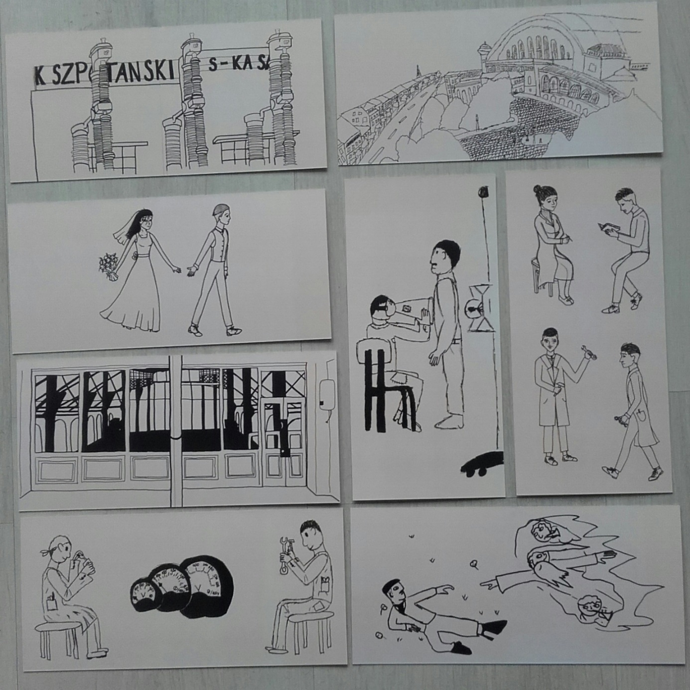

1. Collection of original technological equipment, equipment from the collection of the Electro-technical Institute in Warsaw. 2. Art workshops: implementation of an installation referring to the phenomenon of electricity with the use of authentic electrical devices carried out by Edyta Bystroń with the support of Paweł Brzeski.

3. Installation of the installation in the premises of the WCK, ceremonial inauguration.

STAGE IV OPEN DISCUSSION FORUM (30 hours of workshops)

1. Organization of the forum by Ewa Andrearczyk; selection of participants, topics and experts. 2. Journalism workshops preparing for participation in the forum in schools.

3. Workshops on public speaking for selected participants conducted by Patryk Kuś. 4. Logistics, promotion and direct preparation of the forum.

5. Opening of a youth discussion forum conducted using the open space technology method, i.e. a method of working with large groups that enables dialogue with the entire organization. Invited experts will also take part in the forum. Topics discussed at the forum will revolve around modern education, our project history or creative activities. The final selection will be made by young people during the workshops.

STAGE V EVALUATION AND PROMOTION OF PROJECT RESULTS

1. Meetings and conversations with the audience, residents of Wawer and project participants: young people and artists. 2. An article summarizing the project in the local press and social media.

### Project results

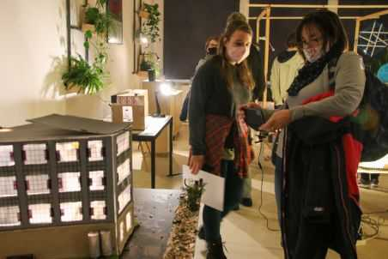

Material:

- the first ever animated film about Kazimierz Szpotański made by young people.

- a youth exhibition/art installation made of electrotechnical materials, equipment and objects: original insulators, motors, made available and recovered from the Electrotechnical Institute in Warsaw.

- photo and video documentation of the project.

- extensive description of Kazimierz Szpotański and his factory on the Wikipedia page.

- creation of a dedicated website.

Intangible:

- historical education: knowledge about Kazimierz Szpotański, historical knowledge about the interwar period, - artistic, social and cultural education of participants and recipients, broadening horizons and breaking stereotypes of patriotic attitudes.

- acquiring the competence to creatively combine science with various art disciplines.

- social integration and identity building around local history.

- increasing the involvement of young people in creating their reality.

The assumed long-term effect of the project was to arouse in young people the need to carry out their own creative activities, the need to discover and constantly learn, as well as to react to constant changes and the ability to accept it. We hope that after the project new close acquaintances were established among project participants.

For the institution, the long-term effect was to increase recognition and broaden the program offer. The project was one of the first such extensive experimental activities. We would like to turn such projects into regular informal education of young people in the field of interdisciplinary arts permeating each other.

The most important in the project was giving the voice to young people and make them the co-authors that are using technology, discovering and telling the story of Szpotański anew, in their contemporary language, and interpret his achievements in the scientific, social and political fields.

## Case study II: “Pine that connects people” – how to activate among interesting and important local symbol

### The background and objectives

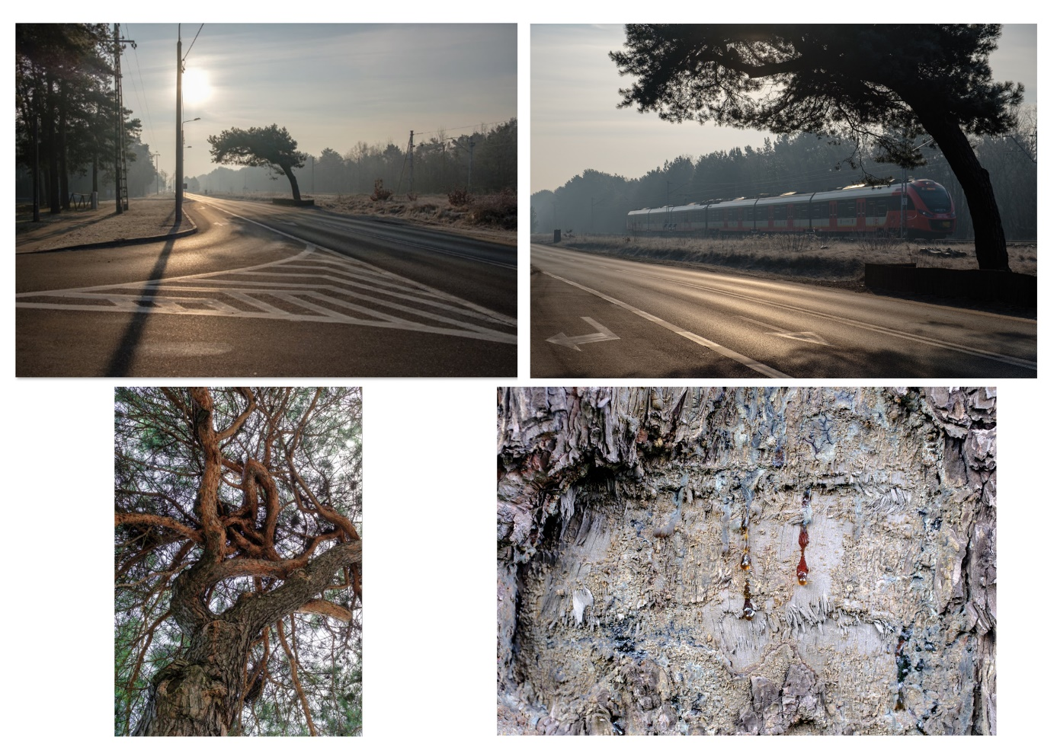

„Pine that connects people” was the very special project created in Wawerskie Centrum Kultury spontaneously as a reaction to grassroots activities of the local community. The idea behind the project was to appreciate and popularize social activities related to the tree-symbol that finally got a name „the Falenicka Pine”.

„The Falenicka Pine” is the unique, arc-shaped pine growing over the main road in Falenica (one of Wawer’s estates) that looks a bit like an entrance gate to the Wawer’s district.

The pine became more widely known to the public in 2018, when its age was estimated at about 50 years. At that time, it was announced that due to plans to modernize railway line and build the underground passage it had to be cut out. These plans sparked plety of protests.

Initially, the Association „Together For Wawer” and local activists were involved, then „the City Is Ours” Organisation and other people joined in. The authorities of Warsaw initiated the procedure for recognizing the tree as a natural monument, and the council of the Falenica estate submitted it to the Tree of the Year competition in the 2020 edition. In this competition, the pine took second place.

As Wawerskie Centrum Kultury was observing the whole proces, the authors of the project „Pine that connects people” - Marta Różańska and Magdalena Magrzyk noticed a great potential for activities in the field of cultural education and support for local identity, based on a sense of responsibility for the common good, which is nature. They implemented their project between August - October 2021 targeting it to all inhabitants of Wawer - children, teenagers and adults.

### Methods and activities

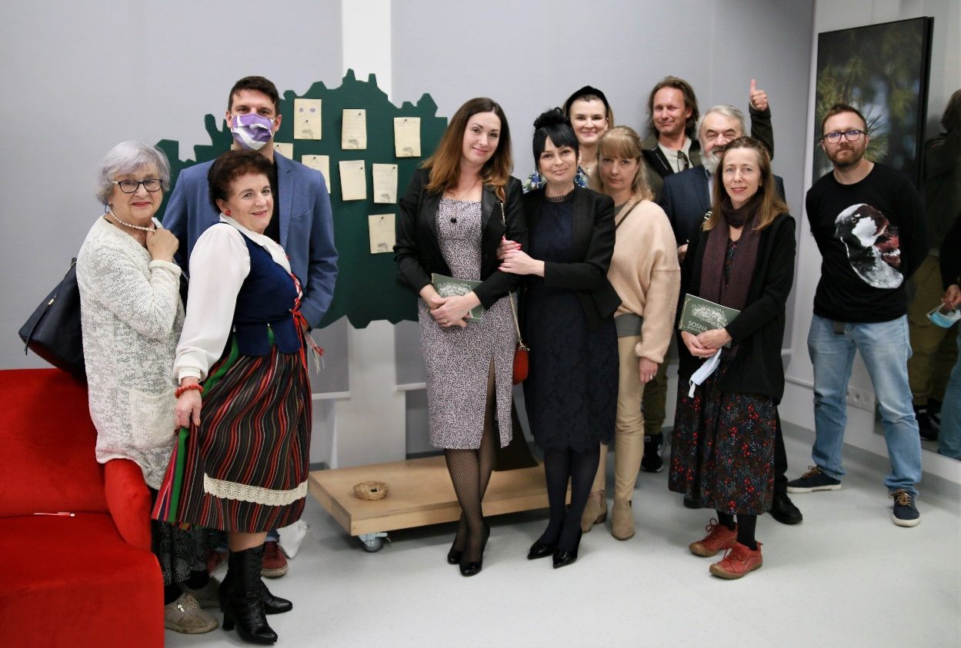

**"Pine that connects" was created as a series of events and workshops.** The project consisted of

- organizing a guided walk

- story-telling classes

- nature workshops

- a photo exhibition with a vernissage, the "Pine Festival" meeting

- creating a space for animation and educational activities using a mobile mockups and brochures.

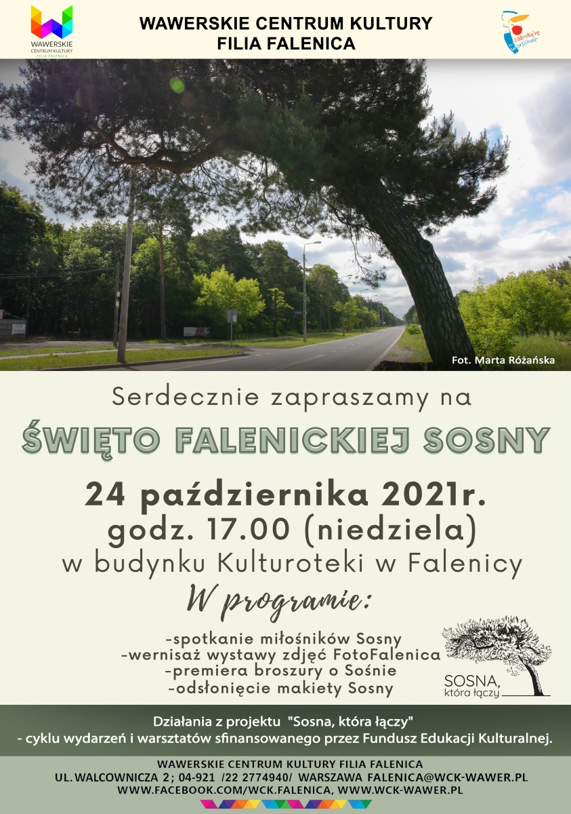

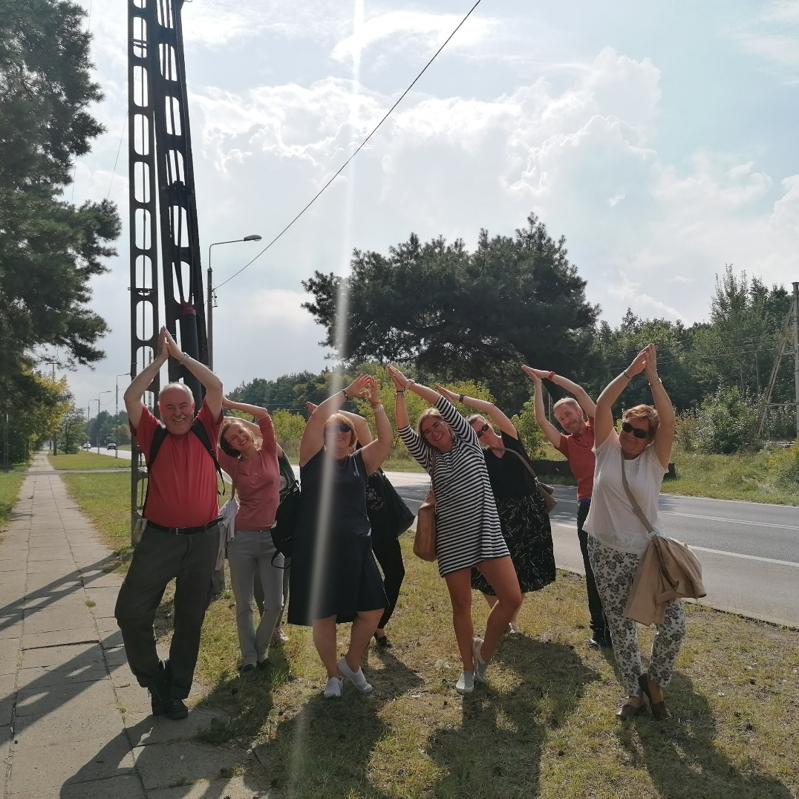

The entire community was mobilized to vote for the pine in the "Tree of the Year" competition.

### Project results

The effects of the project include popularization of natural heritage, which contributes to the development of pro-ecological attitudes, such as sensitization to nature, a sense of responsibility for it, treating it as an important element of life. We also managed to collect memories, anecdotes, photographs, etc. related to the tree-symbol in the brochure and create space for further activities inspired by Falenicka Sosna.

Initially, the Regional Directorate for Environmental Protection (RDOŚ) in Warsaw decided that the condition of the tree did not allow it to be protected, because it poses a threat to the infrastructure. As a result of the city's appeal, the General Director for Environmental Protection overturned the previous decision of the RDOŚ in its entirety and the proceedings were resumed and the City Council of the Capital City of Warsaw established this form of protection.

The activity related to the protection of the pine against felling made it a local attraction and a symbol of activities for the benefit of nature but also integrated and activated the entire local community.

## Case study III: “Active in Radość estate” (or „Active in Joy”) – culture that connects the community during crisis situations

### Background and objectives

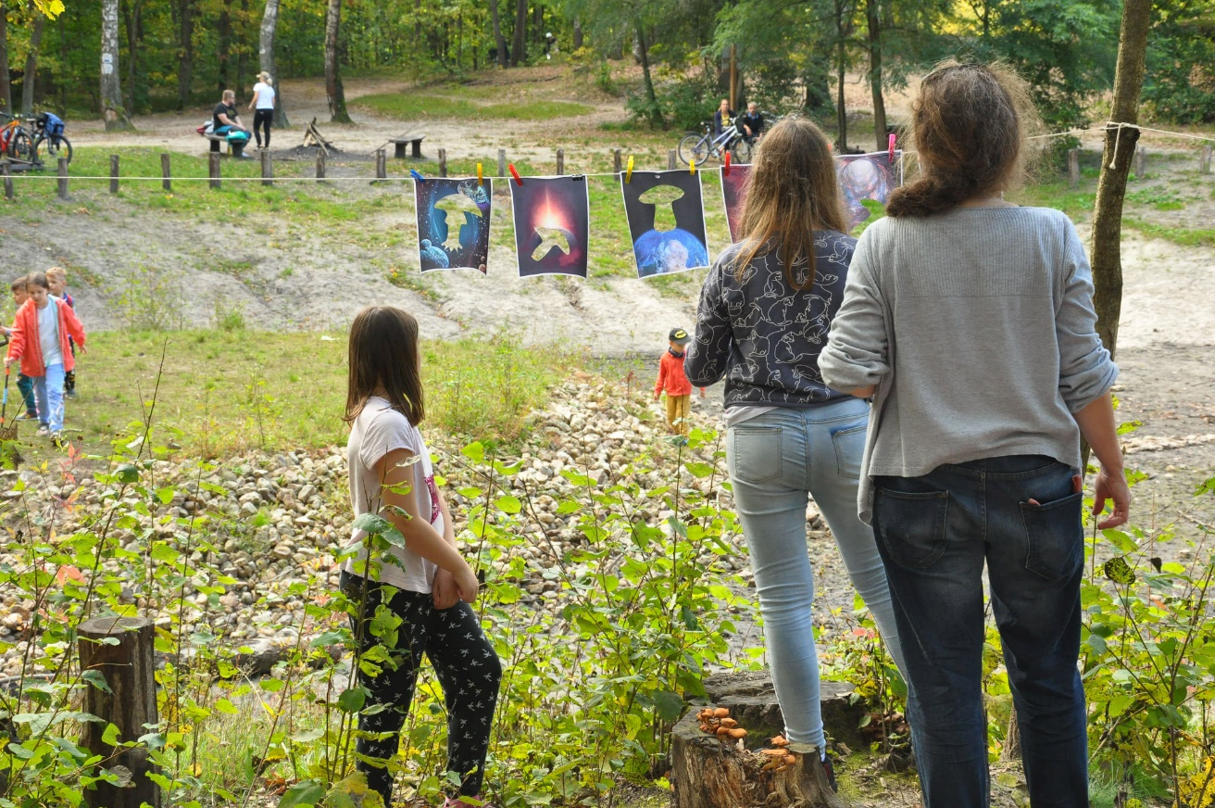

Active in Radość is a large long-term project implemented in two cycles by the Branch of WCK Radość from January 2021 until today.

The Active in Joy project was our response to the crisis situation related to the pandemic. Meetings in the open air have become an opportunity to contact other people - an effective way to break the stagnation in interpersonal contacts, active participation in attractive interdisciplinary activities during the period of isolation and bans on participation in meetings and activities in closed spaces. This is an extraordinary example of how culture overcomes the crisis and can revive the local community even in lockdown.

It is a series of art and theatre workshops, meetings with the history of literature and art, and outdoor movement. The name of the project refers to Joy as a estate in Wawer district, but above all as serenity and the joy of joint creative action. The project is addressed to all residents of Wawer from 0 to 100 years old. From older residents, we get knowledge and curiosities related to our locality. We design this project as inclusive and easy-accessible for various inhabitants of Wawer.

### Methods and activities

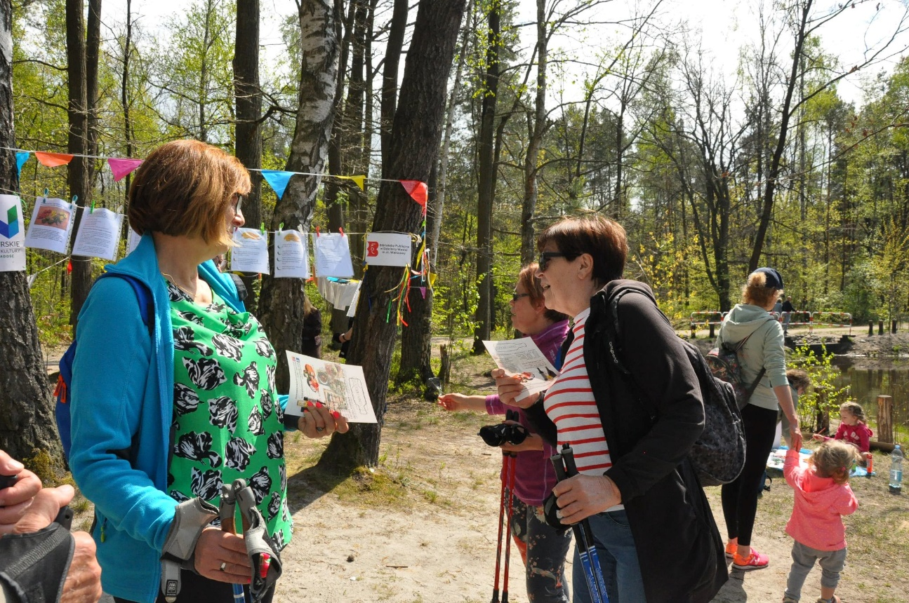

Workshops are held one Sunday a month by the Czarny Staw lake in the Mazovian Landscape Park, a favourite resting place for the inhabitants of Radość.

It is distinguished by the combination of culture and nature. We offer interdisciplinary and non-stereotypical educational activities in the forest space.

We are a pleasant surprise, we do not require preparation for classes and we give tools for creatively spent time. That is why residents are very quickly willing to engage in our artistic challenges. They are curious and surprised "what can we do together in the forest".

The assumption of the workshop is to combine non-stereotypical topics and educational activities, the aim of which is to surprise, interest participants and provoke non-obvious, non-stereotypical activities. We engage recipients in accordance with their capabilities, abilities, desires and interests - literature, art, music, healthy eating, ecology. Sometimes we encourage you to step out of your comfort zone and do something completely new. We show that you can be creative in many ways. We encourage you to look for inspiration and activity using various means and tools of expression.

Since our project was born out of the need to contact the inhabitants, we started the first activities in this direction already in January 2021, initially leaving the residents with thematic tasks near the Czarny Staw Lake.

An example of activities under this project was the "Ornithological Walk". A forest game route was prepared in the forest, the subject of which concerned ornithological issues. The recipients were children with their parents or guardians. Places with tasks have been placed along the designated route. The task was to find cards marked with the WCK logo, on which there was a QR code. After scanning the code, the participant could listen to information about the bird and see what it looks like.

Each meeting have a different topic connected with art, nature, healthy diet, literature, etc.

### Project results

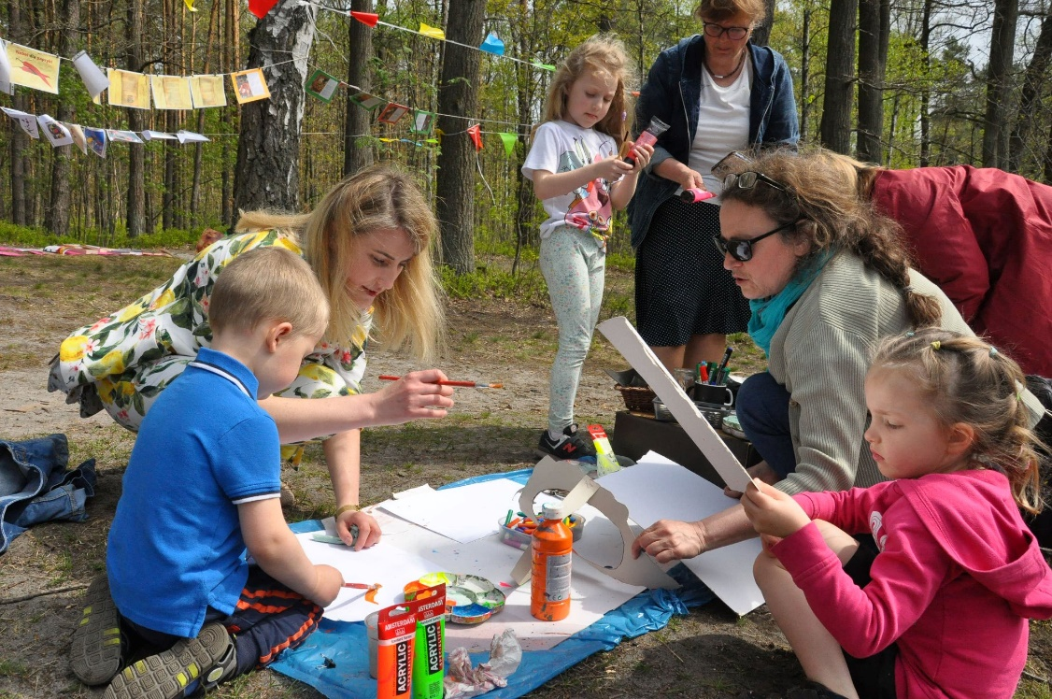

We made the Sunday walk more attractive with unexpected activities and we created a lot of fun for a group of children, adults and disabled people. But in the deeper sense – we are successfully showing that being creative is possible for anyone and anywhere. We are also creating a great, informal space for the local inhabitants to meet each other and do something together.

Our conclusion: the more open and branched we are, the more people we attract. It is also a way to attract new customers. Going outside (from the comfort zone) turns out to bring great satisfaction, it turns out that in the lockdown you can have contact with the local community and find a way to carry out your tasks. This formula also works well in the normal times.

## Perspectives from the case studies

In our Case Study we presented 3 projects that we evaluated as highly successful in the Micropolis context – as projects that build and connect the local community. They also illustrate how cultural centre can support and integrate the local community in the situations when:

* The local identity is not very strong, there are plenty new or almost new inhabitants with no bonds with local communities – then it’s a great idea to look for new local symbols (like pine), inspiring people (like local historical or current model personalities or successful persons) or nice places that can be also used as meeting spots and open-air cultural centres (like Czarny Staw Lake).
* There is a need to overcome the intergenerational, intercultural or social divisions and to attract new participants to the cultural activities – all three projects show that the successful, inclusive cultural project with magnetic power needs:

1. choosing the topic that is both interesting, inspiring and important for the local community
2. combining many fields (like history, art, science, new technologies or art nature, heritage or art, literature, nature, healthy lifestyle)
3. using various artistic means (film/ photography/ manual workshops/ literature/ storytelling/ using public space and changing it, etc)

- There is a crisis situation (like during COVID pandemic or with the outbreak of war in the Ukraine or simply – when the beutiful natural monument is in danger) and people need more emotional suport and more community feelings like safety, trust, hope, cooperation and common fight with problems. Than such projects as „Active in Joy” or „Pine that connects people” have double power and sense.