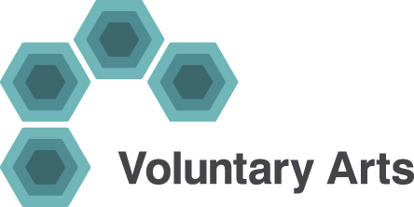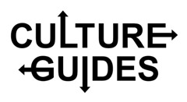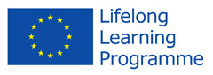

**Culture Guides – interim report**

**27 January 2014**

* **St Helens, Merseyside** – Culture Guide overview was emailed to Maria Brewster, key contact for the Creative People and Places (Heart of Glass) programme based in St Helens. Maria very keen to be involved and the Library network in St Helens could also be a partner on this project too. Laraine is meeting with them to follow up on this on 28 January. St Helens has been a really good local authority to work with on Up for Arts campaigns, so this should make an ideal site for this project.
* **Swale & Medway, Kent** – Culture Guide overview was emailed to Voluntary Arts’ Creative People and Places (CPP) partner in Kent. We should know soon how they want to take this forward (they are discussing and ratifying our partnership agreement on 29 January). They seemed very keen on the Culture Guide project when Laraine met with them on 10 January, including how they would be able to embed this initiative into the work of local consortia partners.
* **Pontypool, Torfaen** – Culture Guide overview was emailed to Verity Hiscocks, Arts Development Manager at Torfaen County Borough Council. Torfaen is a ‘Communities First’ area representing the most disadvantaged people in Wales’ most deprived areas, with the aim of contributing to alleviating persistent poverty. Meeting scheduled with Verity, along with other potential stakeholders in Torfaen, on 10 February.
* **Wrexham** – Culture Guide overview was emailed to Lynn Mealings at Arts Agency and Rebeccah Lowry, Regeneration Manager at Wrexham County Borough Council. As well as being a Communities First area, Wrexham is the location for Welsh National Opera’s community outreach work, and we plan to partner with them on another of our local pilot projects aimed at the participants of time-limited community arts initiatives. Meeting planned with Rebeccah, WNO and AVOW (Association of Voluntary Organisations in Wrexham) week beginning 17 February.